**MongoDB Assignment 1**

1. Create a new database called student_management.

QUERY— use student_management

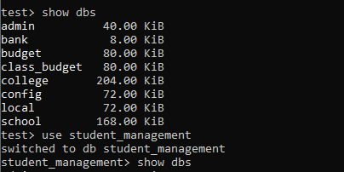

1. Create a collection called students in the student_management database.

QUERY—db.createCollection(“student”)

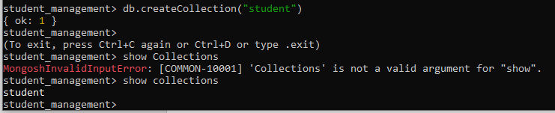

1. Insert at least five student records into the students collection. Each record should have the following fields:

* student_id (integer)
* name (string)
* age (integer)
* department (string)
* courses (array of strings)
* grade (string)

QUERY—

db.student.insertMany([{student_id:101,

name:"Akshay Kumar",

age:23,

department:"BCA",

courses:["C++","Python"],

grade:"A"

},

{student_id:102,

name:"salman khan",

age:24,

department:"Btech",

courses:["HTML","PHP"],

grade:"B"

},

{student_id:103,

name:"Shahid kapoor",

age:20,

department:"BSc",

courses:["HTML","Python","Javascript"],

grade:"C"

},

{student_id:104,

name:"John abraham",

age:19,

department:"BCA",

courses:["Javascript","HTML","AsP.net"],

grade:"D"

},

{student_id:105,

name:"Amir khan",

age:24,

department:"Btech",

courses:["Javascript","HTML"],

grade:"B"

}

])

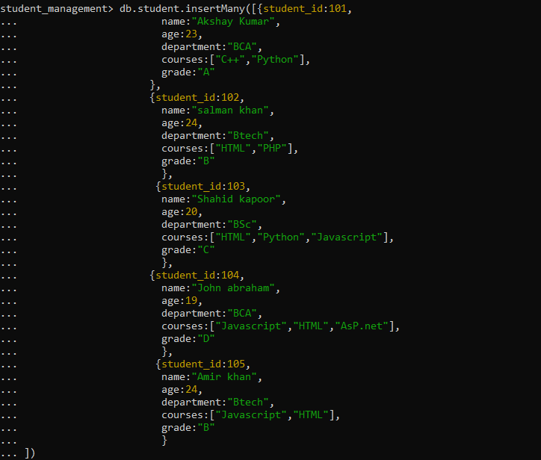

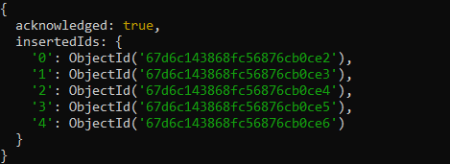

# after db.student.find()

We get,

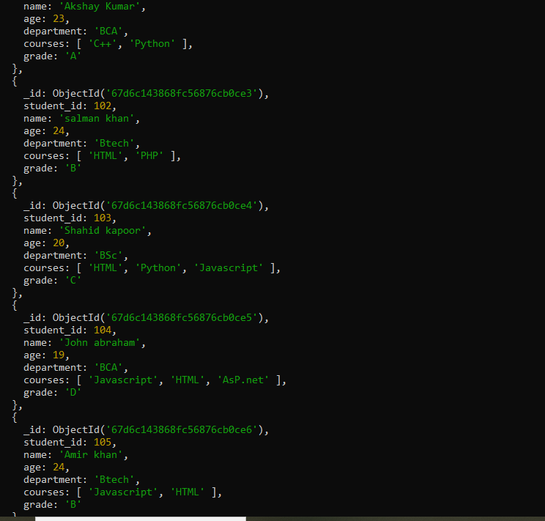

1. Query the Collection:

Write queries to perform the following tasks:

* Retrieve all students who are in the "Computer Science" department.

QUERY—

db.student.find({department:"Btech"})

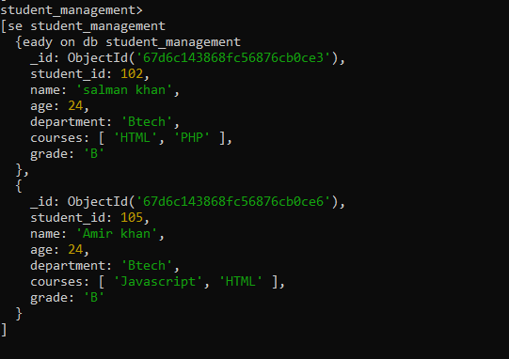

* Retrieve students who have an age greater than 21.

QUERY—

db.student.find({age:{$gt:21}})

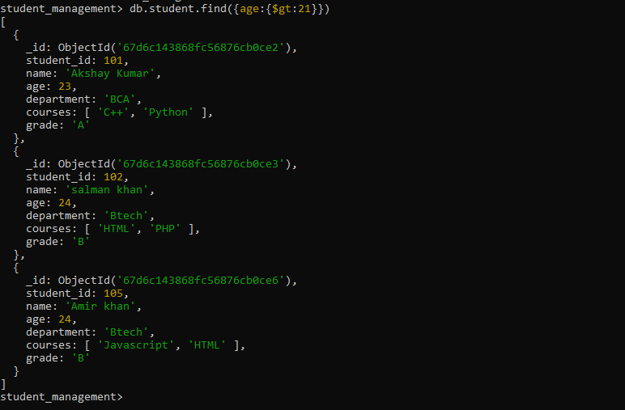

* Retrieve students who are taking the "Database Systems" course.

QUERY—

db.student.find({courses:"HTML"})

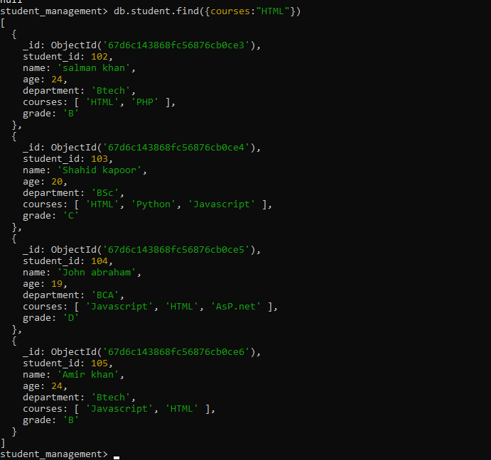

* Retrieve students with a grade of "A".

QUERY—

db.student.find({grade:"A"})

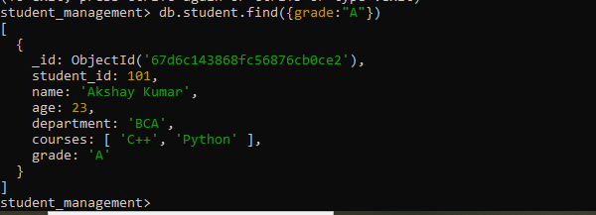

1. **Update Documents:**

* Update the age of a student with student_id 101 to 21.

QUERY—

db.student.updateOne({student_id:101},

{$set:{student_id:21}}

)

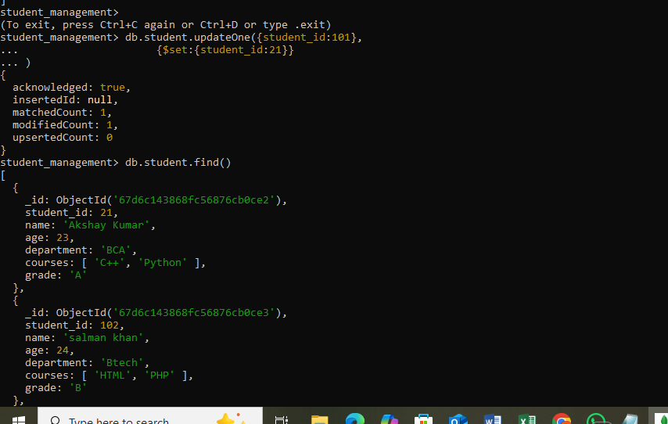

* Add a new course, "Machine Learning", to the courses array for students in the "Computer Science" department.

QUERY—

db.student.updateMany(

{ department: "Btech" },

{ $addToSet: { courses: "Machine Learning" } }

);

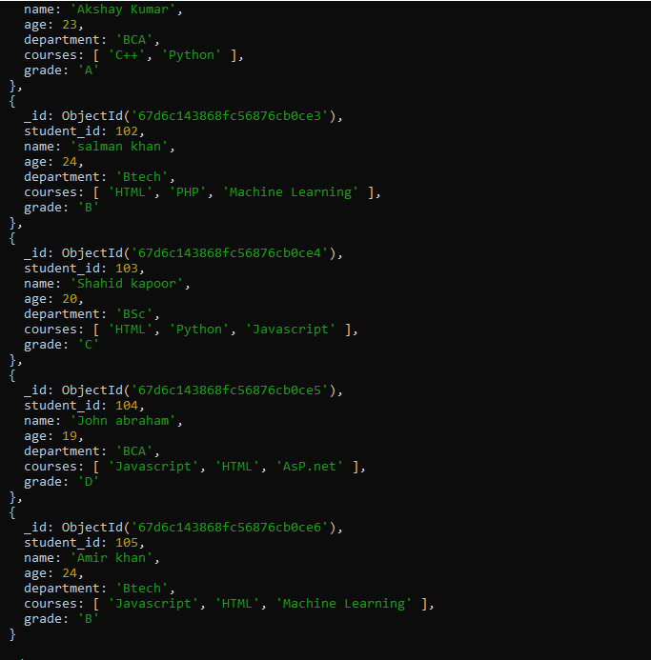

1. **Delete Documents:**

* Delete a student record with student_id 105.

QUERY—

db.student.deleteOne({student_id:105})

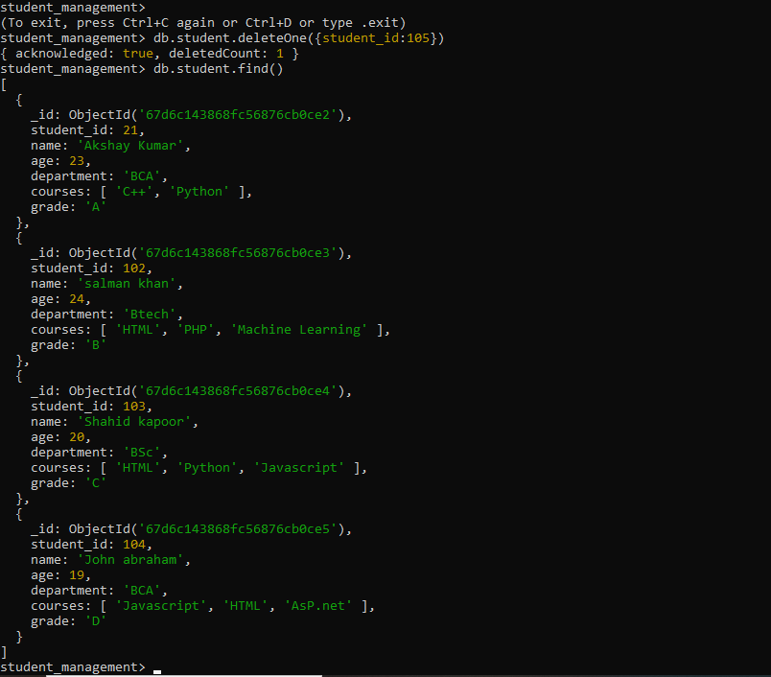

* Delete all students who have a grade lower than "C".

QUERY—

db.student.find({grade:{$lt:"C"}})

